Brachial plexus
Etymology: plexus – network
Brachial – related to brachium – arm

Formation:
- Union of ventral rami of C5, 6, 7, 8 and T1
- Sympathetic fibres communicates with rami
- Prefixed
  - Large C4
  - Small T1
- Postfixed
  - Large T2
  - Small C5
[TIP]Exit of roots - Pass between scalenus anterior and scalenus medius
[NOTE]Derive a part of prevertebral fascia that continues around the brachial plexus and axillary vessels as - Cervicoaxillary canal
[TIP]Watch the video
[YOUTUBE] https://www.youtube.com/watch?v=wZtKFrjVpaQ

Components
- Roots
  - ventral rami of C5, 6, 7, 8 and T1
- Trunks
  - C5 and C6 unite to form upper trunk
  - C7 continues as middle trunk
  - C8 and T1 unite to form lower trunk
- Divisions
  - Each trunk divides into anterior and posterior divisions
  - Posterior divisions supply extensors
- Cords
  - Anterior divisions of upper and middle trunks unite to form lateral cord
  - Anterior division of lower trunk continues as medial cord
  - Posterior divisions of all trunks unite to form posterior cord

[CLINICAL]Cords are named after their relations to second part of axillary artery

Erb’s point
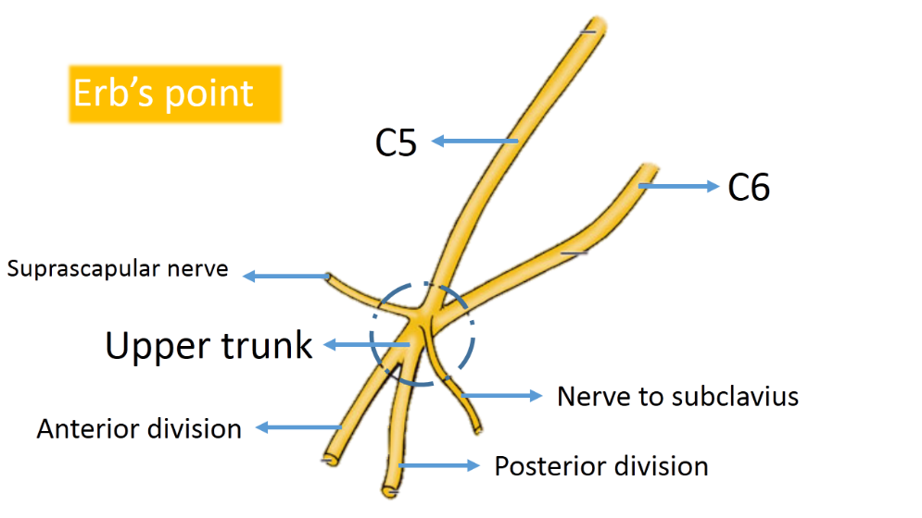

Formation of brachial plexus
[TIP]Watch the video
[YOUTUBE] https://www.youtube.com/watch?v=G32oVBwG-7Q

Brachial plexus diagram
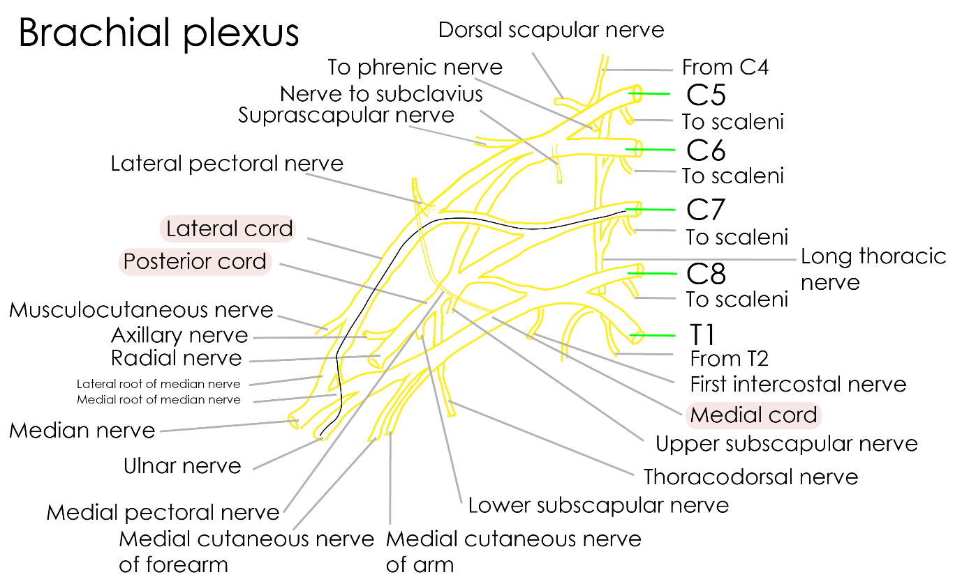
[TIP]Learn to draw diagram
[YOUTUBE] https://www.youtube.com/watch?v=g-TJF3OQ1dg

Branches from roots and trunks
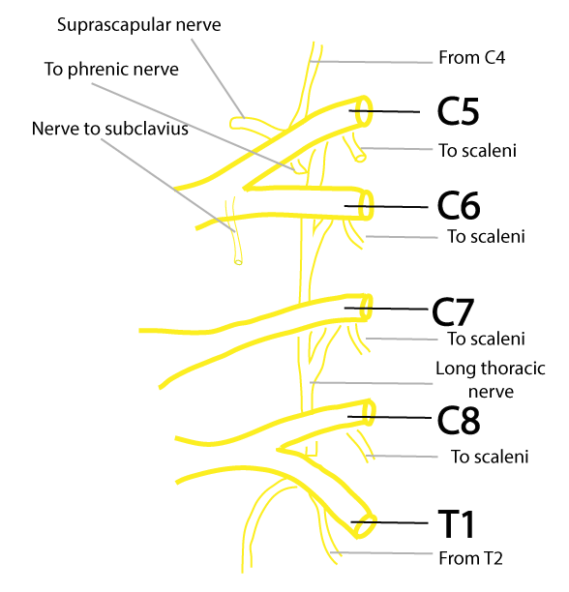

Branches from cords of brachial plexus
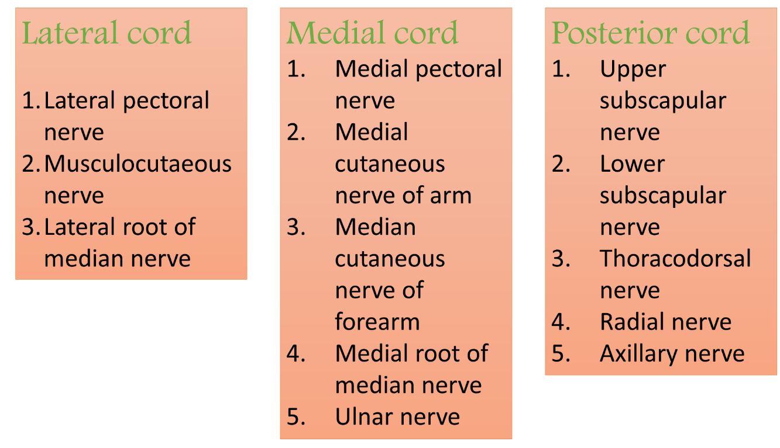

Approaches to brachial plexus block
- Interscalene approach
  - The needle is inserted 3-4 cm above the clavicle and advanced at an angle almost perpendicular to the skin plane in between scalenus anterior and scalenus medius
- Supraclavicular approach
  - The needle is inserted first in an anteroposterior direction 2.5 cm lateral to the clavicular insertion of sternocleidomastoid, almost perpendicularly to the skin
- Axillary approach
  - The needle is inserted through the axilla – after identifying the axillary artery pulsations

Brachial plexus injury
- Motorcycle accidents are the most common cause
- Other etiologies are
- Birth injuries
- Missile + stab wounds
- Traction applied to plexus

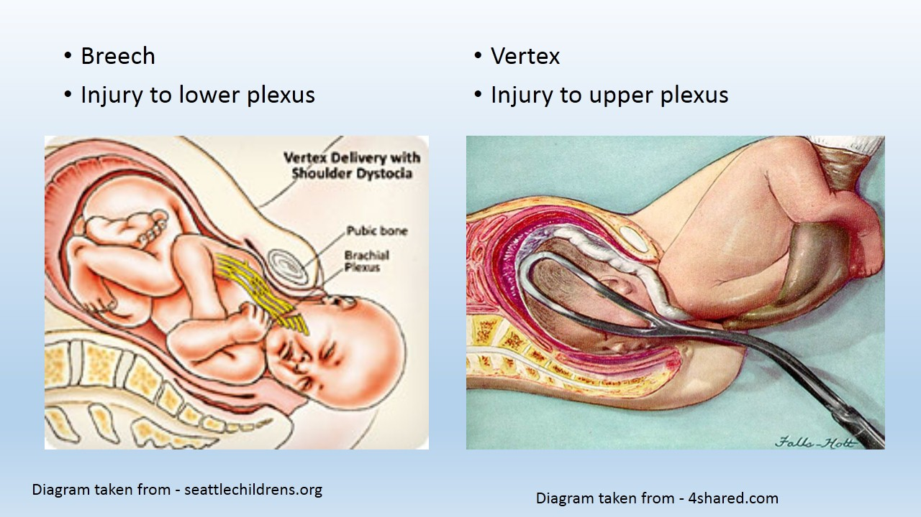

Upper plexus injury – Erb’s palsy
  - Extended at the elbow
  - Flaccid at the side of the trunk
  - Adducted and internally rotated
  - Policeman tip hand deformity

Lower plexus injury – Klumpke’s palsy
  - abduction – deltoid
  - external rotation – infraspinatus & teres minor
  - flexion of the elbow – biceps, brachialis, brachioradialis
  - supination – supinator

